Test manual and Test automated

1-Test manual
# Source: AI Source: Provided by: [Data Path: Persons Table -> ID Column: 1, Name_En Column: Motasem Essam] -> From: [ChatGPT] on [8/22/2025]
A test manual (or more accurately, manual testing) is a type of software testing done by a human tester without using automation tools to execute the test cases.

🖐️ Definition
# Source: AI Source: Provided by: [Data Path: Persons Table -> ID Column: 1, Name_En Column: Motasem Essam] -> From: [ChatGPT] on [8/22/2025]
Here’s what it means in simple terms:
- It’s the process of checking the software manually, step by step, following written or understood test cases.
- A tester acts as the end-user and tries out different inputs, clicks, navigation, and checks whether the software behaves as expected.
- No scripts or automation tools run the tests — it’s all human interaction.

🔹 Key Characteristics
# Source: AI Source: Provided by: [Data Path: Persons Table -> ID Column: 1, Name_En Column: Motasem Essam] -> From: [ChatGPT] on [8/22/2025]
- Human-driven: A tester executes the tests.
- No coding/scripts required: Done without automated frameworks or tools.
- Useful for:
  - Exploratory testing.
  - Usability testing (user-friendliness).
  - Small projects or where automation is too costly or unnecessary.

🆚 Manual Testing vs. Automated Testing
# Source: AI Source: Provided by: [Data Path: Persons Table -> ID Column: 1, Name_En Column: Motasem Essam] -> From: [ChatGPT] on [8/22/2025]
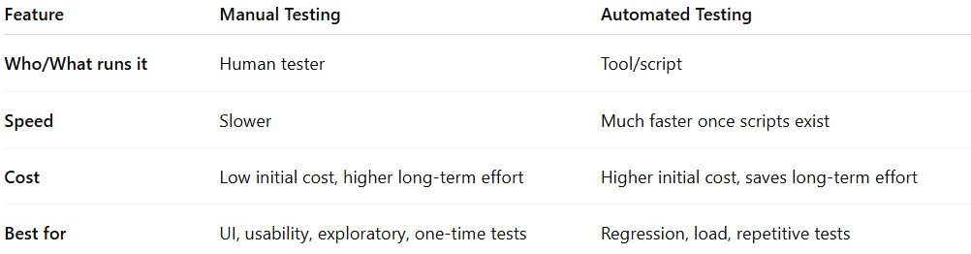
Feature | Manual Testing | Automated Testing
Who/What runs it | Human tester | Tool/script
Speed | Slower | Much faster once scripts exist
Cost | Low initial cost, higher long-term effort | Higher initial cost, saves long-term effort
Best for | UI, usability, exploratory, one-time tests | Regression, load, repetitive tests

💡 Simple example:
# Source: AI Source: Provided by: [Data Path: Persons Table -> ID Column: 1, Name_En Column: Motasem Essam] -> From: [ChatGPT] on [8/22/2025]
You have a login page. In manual testing, the tester:
- Opens the browser.
- Types username and password.
- Clicks “Login”.
- Checks whether the expected page loads correctly.
- Repeats for different input scenarios (valid, invalid, empty fields).

Test Manual Document
# Source: AI Source: Provided by: [Data Path: Persons Table -> ID Column: 1, Name_En Column: Motasem Essam] -> From: [ChatGPT] on [8/22/2025]
Perfect 👍 Now we’re talking about something different: a Test Manual Document (sometimes just called “Test Manual”). This is not about doing tests manually, but about a document that explains how to do the testing, usually in a clear, structured way. Here’s what it means:

📄 Definition
# Source: AI Source: Provided by: [Data Path: Persons Table -> ID Column: 1, Name_En Column: Motasem Essam] -> From: [ChatGPT] on [8/22/2025]
- A formal document that describes testing procedures, steps, environments, and data needed to perform tests on a software system.
- It’s like an instruction book for testers — anyone can read it and know what to test, how to test, and what results to expect.

🔹 What it usually contains
# Source: AI Source: Provided by: [Data Path: Persons Table -> ID Column: 1, Name_En Column: Motasem Essam] -> From: [ChatGPT] on [8/22/2025]
- Introduction / Purpose
  - Why this test manual exists and what part of the software it covers.
- Scope
  - Which features, modules, or versions are included/excluded.
- Test Environment
  - Hardware, software, network, or special setups required.
- Test Cases and Procedures
  - Step-by-step instructions:
    - Preconditions (what should be ready before starting).
    - Test steps (what to click, enter, or do).
    - Expected results (what should happen).
- Test Data
  - Specific inputs to use (e.g., usernames, passwords, file types).
- Roles and Responsibilities
  - Who performs each test or approves results.
- Reporting
  - How to log results, where to report defects.
- References
  - Related requirement documents, design specs, or user stories.

🔹 Purpose
# Source: AI Source: Provided by: [Data Path: Persons Table -> ID Column: 1, Name_En Column: Motasem Essam] -> From: [ChatGPT] on [8/22/2025]
- Ensures consistency — all testers follow the same steps.
- Helps new testers quickly understand how to test the system.
- Provides evidence for audits or certifications.

💡 Example (Very simple):
# Source: AI Source: Provided by: [Data Path: Persons Table -> ID Column: 1, Name_En Column: Motasem Essam] -> From: [ChatGPT] on [8/22/2025]
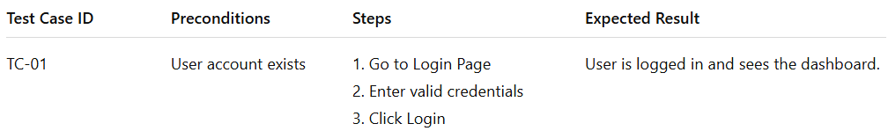
Test Case ID | Preconditions | Steps | Expected Result
TC-01 | User account exists | 1. Go to Login Page2. Enter valid credentials3. Click Login | User is logged in and sees the dashboard.

Summary
# Source: AI Source: Provided by: [Data Path: Persons Table -> ID Column: 1, Name_En Column: Motasem Essam] -> From: [ChatGPT] on [8/22/2025]
So:
- Manual testing = doing tests by hand.
- Test manual (document) = a guide or “instruction book” for how to perform those tests.

2-Test automated
# Source: AI Source: Provided by: [Data Path: Persons Table -> ID Column: 1, Name_En Column: Motasem Essam] -> From: [ChatGPT] on [8/22/2025]
Great follow-up 👍 Now we’re talking about Automated Testing (sometimes people just say “test automated” or “automated tests”).

🤖 Definition
# Source: AI Source: Provided by: [Data Path: Persons Table -> ID Column: 1, Name_En Column: Motasem Essam] -> From: [ChatGPT] on [8/22/2025]
Here’s the meaning in simple terms:
- A software testing approach where tests are executed by tools or scripts instead of by a human manually clicking and typing.
- You write test scripts (programs) once, then a tool (like Selenium, JUnit, Cypress, Playwright, etc.) runs those tests automatically whenever you want.

🔹 Key Points
# Source: AI Source: Provided by: [Data Path: Persons Table -> ID Column: 1, Name_En Column: Motasem Essam] -> From: [ChatGPT] on [8/22/2025]
- Runs without human intervention after setup.
- Fast and repeatable — great for checking the same thing many times (e.g., after every code change).
- Can run day or night, or as part of CI/CD pipelines.
- Used for regression testing (checking that new changes didn’t break old features).

🔹 Advantages
# Source: AI Source: Provided by: [Data Path: Persons Table -> ID Column: 1, Name_En Column: Motasem Essam] -> From: [ChatGPT] on [8/22/2025]
- Speed — much faster than manual testing.
- Accuracy — no human error in following steps.
- Coverage — can test many combinations and scenarios quickly.
- Cost effective over time — initial setup is work, but then it saves labor.

🔹 Limitations
# Source: AI Source: Provided by: [Data Path: Persons Table -> ID Column: 1, Name_En Column: Motasem Essam] -> From: [ChatGPT] on [8/22/2025]
- Initial effort is high — you have to write the scripts and maintain them.
- Not good for everything — some tests (like exploratory testing or checking “look & feel”) still need a human.
- Tools need updates when the system changes (maintenance overhead).

💡 Example:
# Source: AI Source: Provided by: [Data Path: Persons Table -> ID Column: 1, Name_En Column: Motasem Essam] -> From: [ChatGPT] on [8/22/2025]
Instead of a tester opening a browser and logging in manually, an automated script might:
- Open the browser.
- Go to the login page.
- Enter username/password from a data file.
- Click login.
- Verify the dashboard loads.
All in a few seconds — and it can repeat this for 50 test accounts automatically.

real-life examples of test automation scenarios
# Source: AI Source: Provided by: [Data Path: Persons Table -> ID Column: 1, Name_En Column: Motasem Essam] -> From: [ChatGPT] on [8/22/2025]
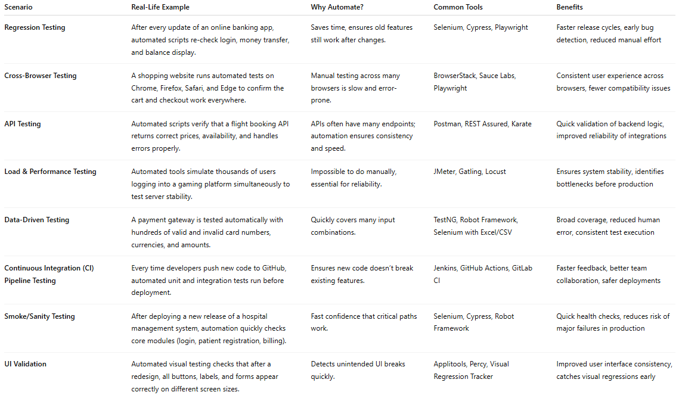
Scenario | Real-Life Example | Why Automate? | Common Tools | Benefits
Regression Testing | After every update of an online banking app, automated scripts re-check login, money transfer, and balance display. | Saves time, ensures old features still work after changes. | Selenium, Cypress, Playwright | Faster release cycles, early bug detection, reduced manual effort
Cross-Browser Testing | A shopping website runs automated tests on Chrome, Firefox, Safari, and Edge to confirm the cart and checkout work everywhere. | Manual testing across many browsers is slow and error-prone. | BrowserStack, Sauce Labs, Playwright | Consistent user experience across browsers, fewer compatibility issues
API Testing | Automated scripts verify that a flight booking API returns correct prices, availability, and handles errors properly. | APIs often have many endpoints; automation ensures consistency and speed. | Postman, REST Assured, Karate | Quick validation of backend logic, improved reliability of integrations
Load & Performance Testing | Automated tools simulate thousands of users logging into a gaming platform simultaneously to test server stability. | Impossible to do manually, essential for reliability. | JMeter, Gatling, Locust | Ensures system stability, identifies bottlenecks before production
Data-Driven Testing | A payment gateway is tested automatically with hundreds of valid and invalid card numbers, currencies, and amounts. | Quickly covers many input combinations. | TestNG, Robot Framework, Selenium with Excel/CSV | Broad coverage, reduced human error, consistent test execution
Continuous Integration (CI) Pipeline Testing | Every time developers push new code to GitHub, automated unit and integration tests run before deployment. | Ensures new code doesn’t break existing features. | Jenkins, GitHub Actions, GitLab CI | Faster feedback, better team collaboration, safer deployments
Smoke/Sanity Testing | After deploying a new release of a hospital management system, automation quickly checks core modules (login, patient registration, billing). | Fast confidence that critical paths work. | Selenium, Cypress, Robot Framework | Quick health checks, reduces risk of major failures in production
UI Validation | Automated visual testing checks that after a redesign, all buttons, labels, and forms appear correctly on different screen sizes. | Detects unintended UI breaks quickly. | Applitools, Percy, Visual Regression Tracker | Improved user interface consistency, catches visual regressions early

degree of test automation
# Source: AI Source: Provided by: [Data Path: Persons Table -> ID Column: 1, Name_En Column: Motasem Essam] -> From: [ChatGPT] on [8/22/2025]
Degree of Test Automation
- Definition:
The extent (percentage or level) to which testing activities are automated compared to being done manually.
In other words, it shows how much of your testing is performed by automated tools instead of human testers.
- Why It Matters:
It helps organizations measure:
  - Efficiency (less manual effort)
  - Coverage (more scenarios tested automatically)
  - ROI (return on investment for automation tools)
  - Planning (how much still needs human/manual testing)
- Examples:
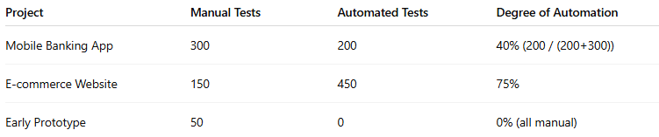
Project | Manual Tests | Automated Tests | Degree of Automation
Mobile Banking App | 300 | 200 | 40% (200 / (200+300))
E-commerce Website | 150 | 450 | 75%
Early Prototype | 50 | 0 | 0% (all manual)
- Common Levels (not official but practical):
  - Low → <30% automated (mostly manual testing)
  - Medium → 30–70% automated (mix of manual & automation)
  - High → >70% automated (majority of tests run by scripts/tools)
- Note:
It’s rarely 100% automated — because exploratory testing, usability, and ad-hoc checks still need humans.

Summary
# Source: AI Source: Provided by: [Data Path: Persons Table -> ID Column: 1, Name_En Column: Motasem Essam] -> From: [ChatGPT] on [8/22/2025]
So, in short:
Aspect | Manual Testing | Automated Testing
Performed by | Human | Tool / Script
Speed | Slower | Much faster
Cost (long term) | Higher | Lower (after setup)
Use cases | Exploratory, usability | Regression, repetitive checks

Different approaches of testing
# Source: AI Source: Provided by: [Data Path: Persons Table -> ID Column: 1, Name_En Column: Motasem Essam] -> From: [ChatGPT] on [8/22/2025]
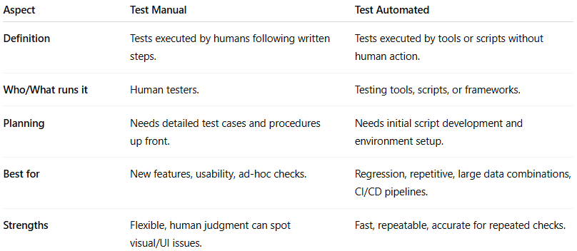
Aspect | Test Manual | Test Automated
Definition | Tests executed by humans following written steps. | Tests executed by tools or scripts without human action.
Who/What runs it | Human testers. | Testing tools, scripts, or frameworks.
Planning | Needs detailed test cases and procedures up front. | Needs initial script development and environment setup.
Best for | New features, usability, ad-hoc checks. | Regression, repetitive, large data combinations, CI/CD pipelines.
Strengths | Flexible, human judgment can spot visual/UI issues. | Fast, repeatable, accurate for repeated checks.

